**OUTPUT**

**Google Chrome Browser:**

**PAGE 1:**

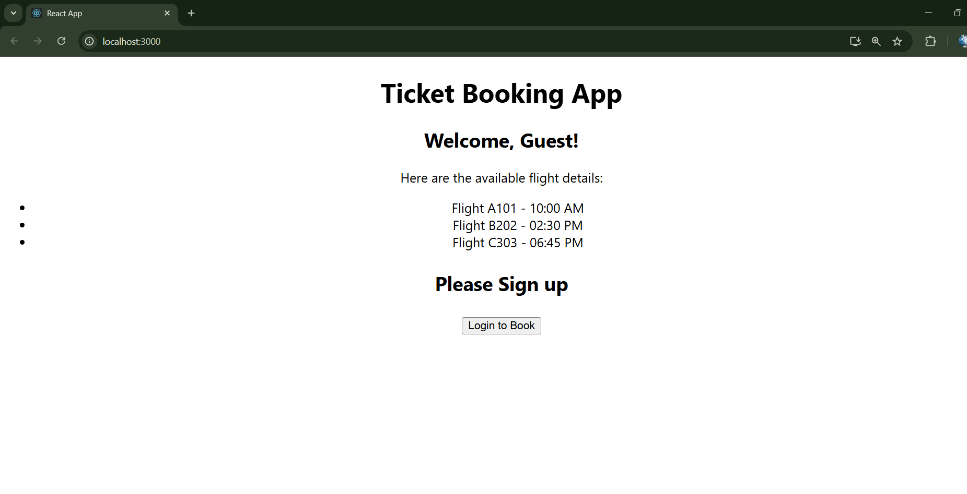

**PAGE 2:**

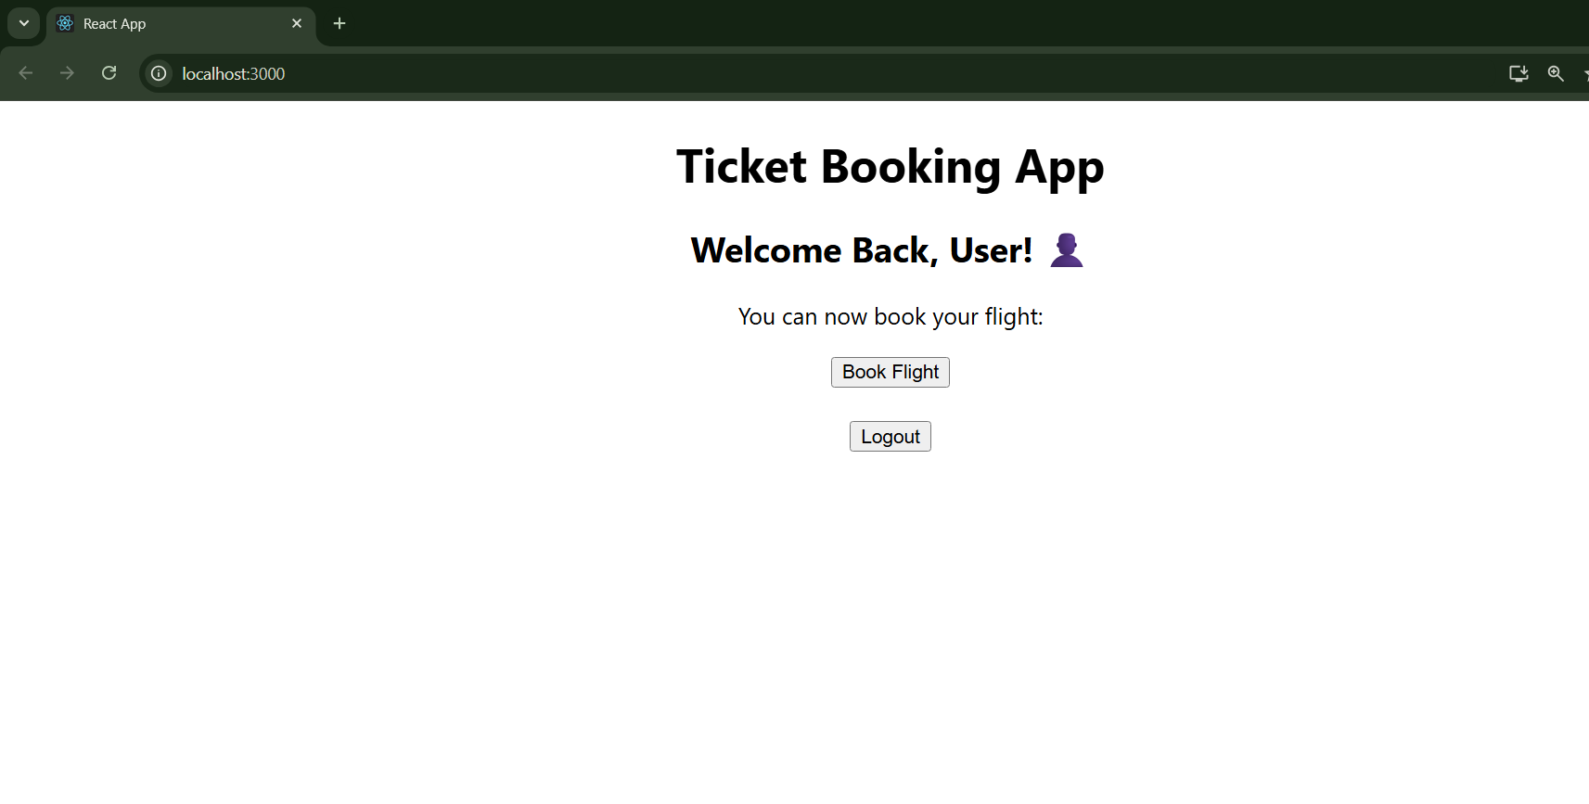

**After clicking ‘Logout’ it returns back to the Guest page (PAGE 1).**

